Practicum Final Exam – Odd Semester Year 2021/2022
Subject |  |  | COMP6579001 – Big Data Processing |  |  | 
Class | : | BA08 |  | Start Date | : 21 January 2022
Lecturer | : | D6198 - Fepri Putra Panghurian, S.Kom., M.T.I. |  | Start Time | : 17:20
Lecturer | : |  |  | End Date | : 21 January 2022
Lecturer | : |  |  | End Time | : 19:20

PERATURAN UJIAN:
Exam Regulations:
- Mahasiswa tidak diperbolehkan berdiskusi dan/atau bekerja sama dengan peserta ujian lainnya
Student is not allowed to discuss and/or work together with other exam participants
- Mahasiswa tidak diperbolehkan untuk membuka dan menyalin dari BUKU atau CATATAN, VIDEO dari pengajar (recording kelas, VBL, Youtube, dsb) dan REFERENSI lainnya
Student isn't allowed to open and copy from any resources such as notes, videos (class recording, VBL, Youtube, etc) and other references
- Mahasiswa tidak diperbolehkan membuka dan menyalin jawaban dari internet (google, stackoverflow, dsb)
Student isn't allowed to open and copy answer from the internet (google, stackoverflow, etc)
- Asisten BERHAK memberi nilai 0 (NOL) bagi peserta ujian yang melakukan segala bentuk kecurangan
Assistant is able to give 0 (ZERO) score for exam participant who does any cheating actions
- Kumpulkan jawaban tepat pada waktunya, apabila terlambat mengumpulkan maka jawaban tidak akan dikoreksi dan nilai mahasiswa adalah 0
Submit the answer on time, if not, then the answer will not be checked, and the students will receive 0 (ZERO)
- Bila Anda tidak membaca peraturan ini, maka Anda dianggap telah membaca dan menyetujuinya
If you have missed to read these regulations, so you are considered to have read and agreed on it



SOFTWARE YANG DIGUNAKAN:
Software will be used:
- Vmware Workstation 16
- VM Cloudera
- Jupyter Notebook

FILE YANG DIKUMPULKAN:
File must be collected:
- IPYNB

PERHATIAN!
Attention!
- Bagi yang mengerjakan tidak sesuai dengan soal, maka akan diberikan nilai NOL (0)
For those who do not work in accordance with the exam case will be marked as ZERO (0)
- Bagi yang mengerjakan tidak sesuai dengan software dan versi yang telah ditetapkan, maka akan tetap dikoreksi dengan software dan versi yang telah ditetapkan
For those who do not work in accordance with the software and specific version will be corrected by the predefined software and version
- Kompres semua jawaban yang akan diunggah. Pastikan format pengumpulan nama file dan ekstensi sesuai dengan format berikut: [NIM]-[NAMA].zip
Compress all file that will be uploaded. Make sure the format for collecting file name and extension according to the following format: [NIM]-[NAME].zip

Soal
Case

Wardlakestone Police Station
Wardlakestone is one of the biggest police stations in New York City. As one of the biggest police stations, of course, they handled many cases and solved the case most of the time. The police chief wants to know the progress of each existing police station. Therefore, as one of the talented staff in the field of databases, you are asked to perform queries and visualization. Below is the Wardlakestone Police Station ERD to help you analyze.
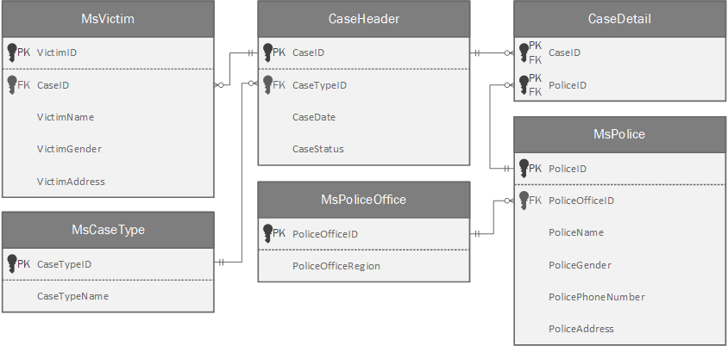
Figure 1. Wardlakestone Police Station ERD

Below is the task you must do to analyze the data.
- Load Data from CSV to Spark
Using SparkSession, read the following CSV files that have been given (MsVictim.csv, MsPoliceOffice.csv, MsPolice.csv, MsCaseType.csv, CaseHeader.csv, CaseDetail.csv).

- Query Analysis and Visualization
You are asked to gain some sales insight about the data. Below are some statements you need to answer. Use SparkSQL to answer the question and the pyplot package to visualize the answer.
- Show the top 5 police office regions that have the most ongoing cases using a bar plot.
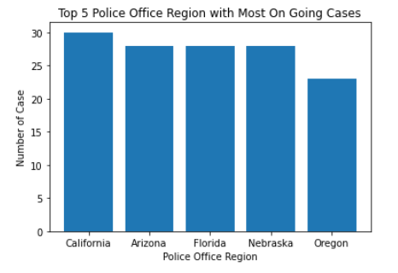
Figure 2. Top 5 Police Office Regions with the Most Ongoing Cases

- Show the total number of victims for each year where the police office region is in Nevada, Washington, Oregon, and California using a line plot.
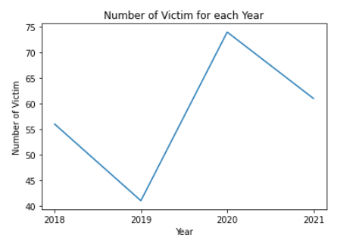
Figure 3. Total Number of Victims for each Year
- Show the percentage of the number of cases for each type of crime where the total number of victims is more than 50 using a pie plot. The type of crime is determined based on the following condition.
Crime Type | Case Type
Violation | Robbery, Drug, Burglary
Misdemeanors | Fraud and Scam, Family Violance, White-Colar Crime
Felonies | Murder, Cybercrime, Terrorism, Foreign Counterintelligence
Table 1. Skateboard Rate Conditions
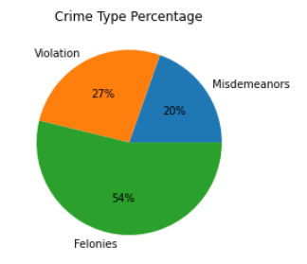
Figure 4. Crime Type Percentage based on Case Type

FitFut
FitFut is a diet food caterer that provides delicious low-calorie meals using fresh and high-quality ingredients. They need to analyze each ingredient's macronutrients to fit the customers' dietary needs. They decided they wanted to create a clustering model that will have 2 clusters, ingredients that are healthy and not healthy. You will be given Clusetering.csv and here is the description of the columns.

Column Name | Description
sugar_level | The food's sugar level in grams. The value is between 1 gr and 190 gr.
calories | The food's calories in cals. The value is between 1 cals and 850 cals.
weight | The food's weight in grams. The value is between 0.5 gr and 2000 gr.
fat | The food's fat content in grams. The value is between 0 gr and 50 gr.
food_color | The food's color. The value is between Black, Coffee, Grass Green, Green, Lemon Yellow, Navy Blue, Purple, Rose, Sunset Red, and Sunset Yellow.
Table 2. Clustering.csv Column
Below are the steps you are required to do to generate the model:
- Load Data
Given the file Clutering.csv and you are asked to load the data using SparkSession.
- Select Features
After you load the data, you need to select important features that will be used for training.
- Data Preprocessing
In this step, please remove any missing values and process the data to suit the following process.
- Transform Data
In this step, transform the raw data so that it is suitable for training. For example, recode the food_color column value to be numbered.

- Normalization
After data preprocessing, you are required to normalize the data. Use the StandardScaler package to normalize the data.
- Generate Model
Next, you are required to generate a model from the data. Use the KMeans package to generate the model into 2 clusters.
- Visualization
After the model is generated, you can visualize the model using the pyplot package. Don't forget to add x-label, y-label, and title for your plot.
😊 Good Luck 😊

